Month Date, Year

C E R T I F I C A T E

Name :

Date of Birth :

Date of Enrollment :

Graduate School :

Year and Program :

This is to certify that the above record is true and correct.

サインを入れてください。

教授名
大学名

September 1, 2022
見本

C E R T I F I C A T E

Name : Osaka Taro

Date of Birth : January 1, 1997

Date of Enrollment : April 1, 2022

Graduate School : Oral Science; Doctoral Program; Graduate School of Dentistry

Year and Program : 1st year of Doctoral Course

This is to certify that the above record is true and correct.

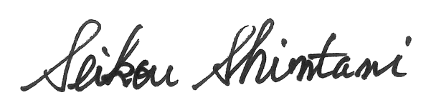

Prof. Seikou Shintani
Tokyo Dental College

